**DATABASE MANAGEMENT SYSTEMS**

**PROJECT REVIEW3**

**Team Members:**

1. Priyanshu Mittal 17BCE0027
2. Diksha Singhania 17BCE0032
3. Divya Gahlot 17BCE0509
4. Achyut Tripathi 17BCE0954

**INSTALLATION GUIDE**

**Requirements:**

1. Downloaded the following softwares from the terminal:

* Neo4j desktop version

Go to the official website [www.neo4j.com/downloads/](http://www.neo4j.com/downloads/) and download the latest edition from the links given on the site according to the OS of your pc.

* Neo4j express edition

From the same official website [www.neo4j.com/downloads/](http://www.neo4j.com/downloads/) go to the expression and download version 3.4.1.

* Flask

Install flask using the pip command directly from the terminal.

* Py2neo

Using the command prompt, install py2neo: pip install py2neo.

* Pypher

Download the query language, from the command prompt: pip install pypher.

* Sublime Text/Any text editor

Any text editor for Running program codes.

1. Imported the following libraries:

* Graph, Relationship, Nodes
* Passlib

**Procedure:**

1. Install the following softwares using the command prompt.
2. We have to give the path of the python 3.4 in the directory and it’s scripts folder too
3. Now we will install the required libraries using command prompt
   * Pip install py2neo
   * Pip install passlib
   * Pip install flask
   * Pip install neo4j
   * Pip install neo4j-driver
4. Once the libraries are installed, create a directory, Flask on the desktop.
5. Create two directories, templates and static in the Flask directory.

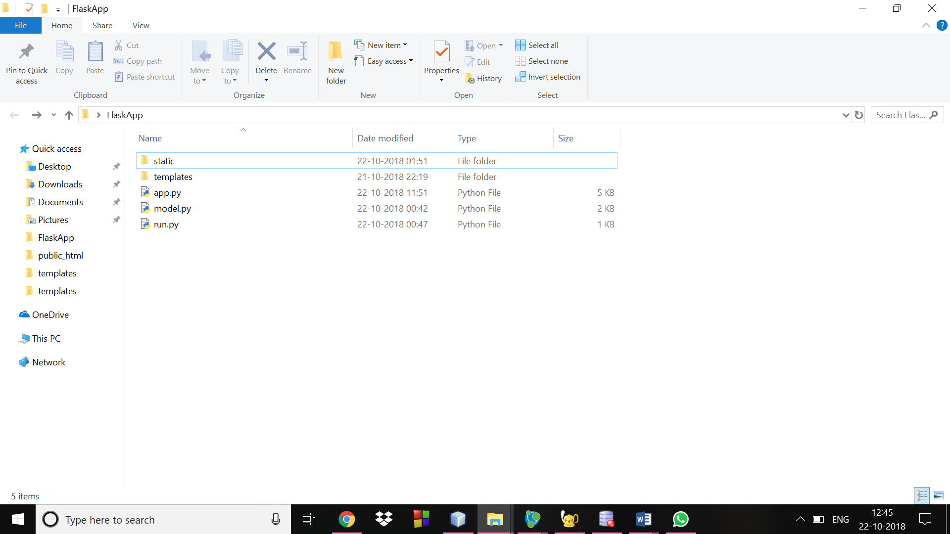

1. The static files have all the javascript files,css files and images for the html files.

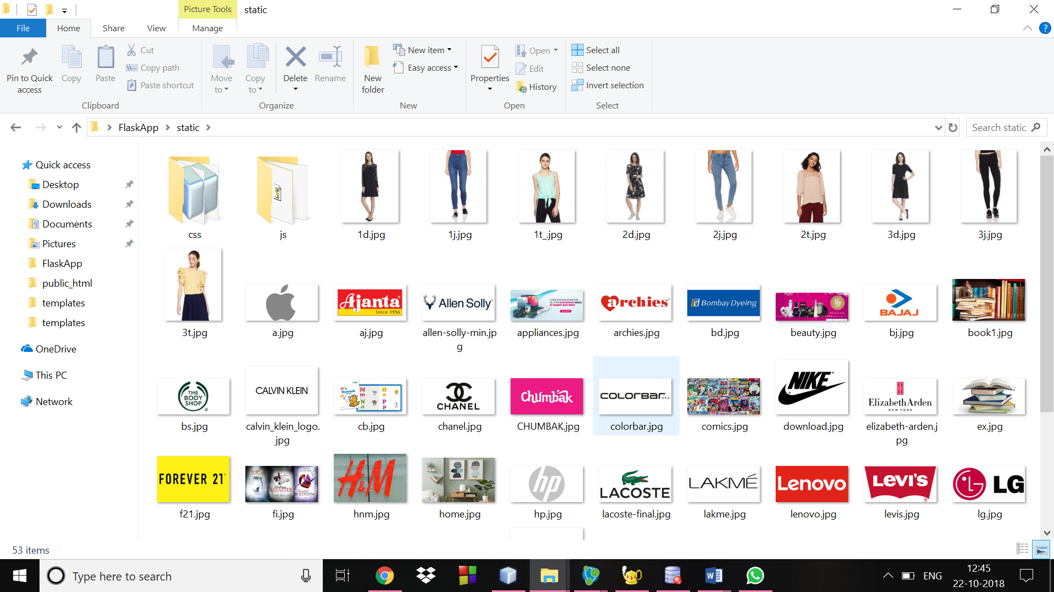

1. Create the folder template and put all the html files into the folder.

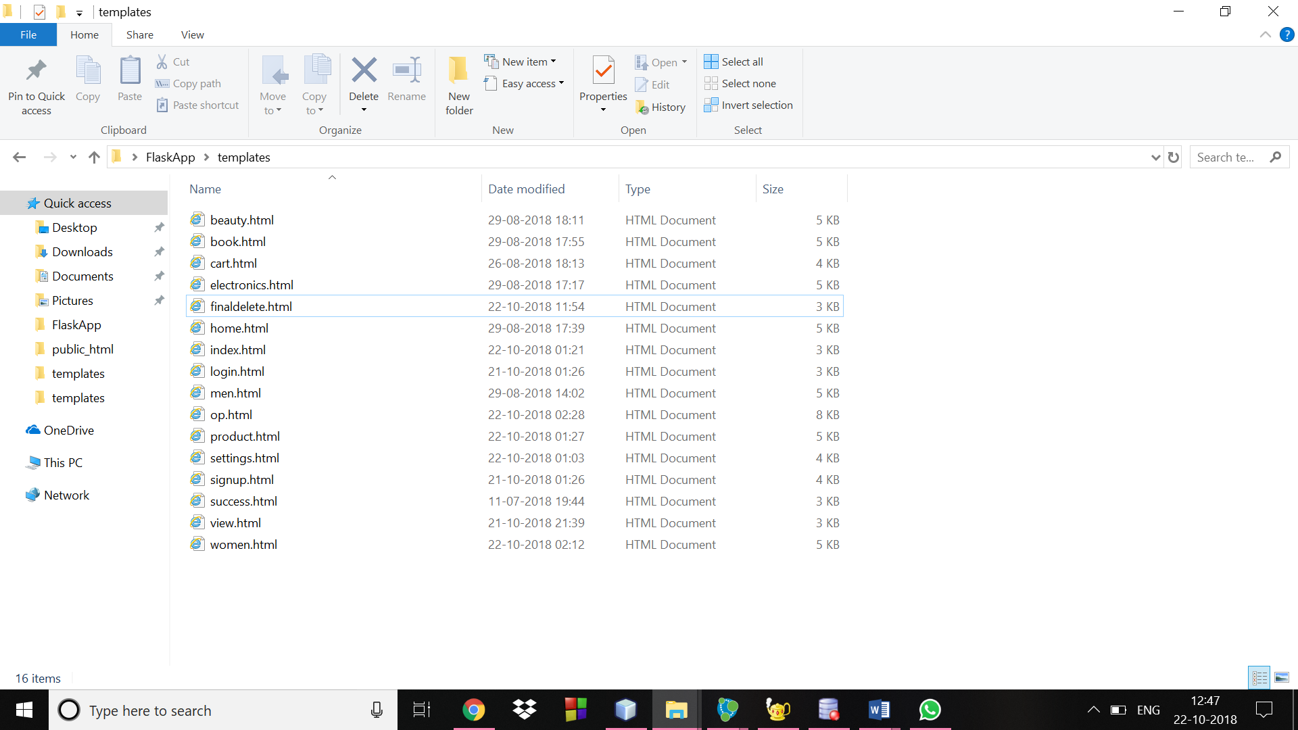

1. In the same folder Flask, create run .py, app.py and model.py.

Now write the required code according to your need for the three .py files and use authenticate to connect to neo4j and execute them. Also import the libraries which have been used such as,

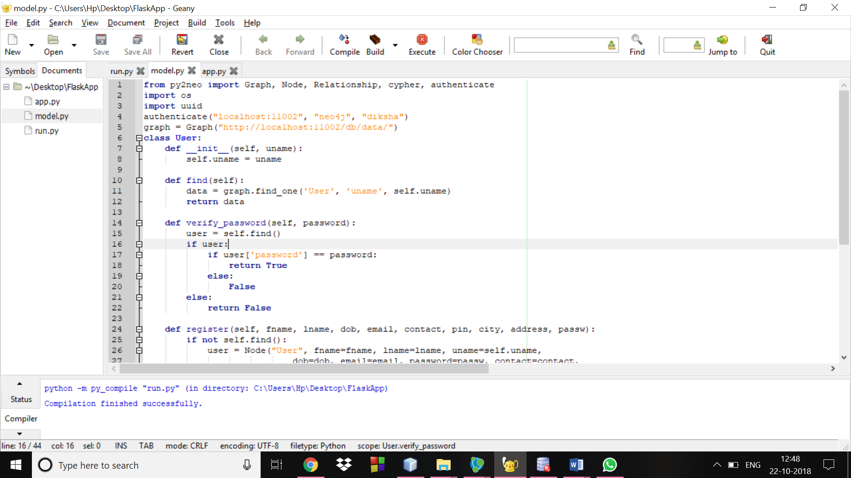

1. A link will popup in the terminal giving you the address of your localhost. Use that to open the website you have created.

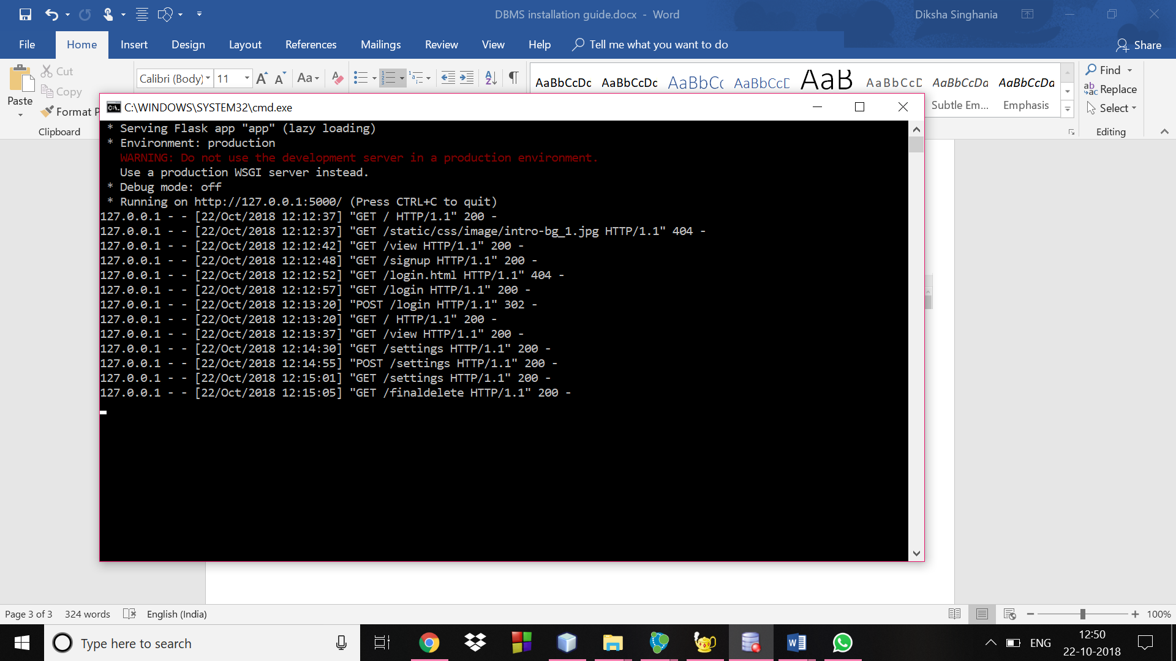

1. Copy the link from the terminal and run it on Google Chrome. It will show the

Required web page.



